Anti-Bullying Help and advice
This resource playlist supports our children and young people's guidance within the Welsh Government Challenging bullying: Rights, respect and equality anti-bullying suite of guidance.

The following are a list of organisations that you can go to for help and advice about bullying and other related issues.
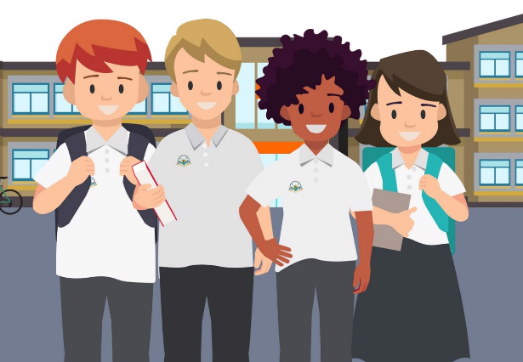
Anti-bullying charities
- Bullies Out – Anti-bullying charity based in Wales. Their e-mentors offer online support (mail@bulliesout.com). https://bulliesout.com/

- Anti-Bullying Alliance – A group of organisations and individuals whose aim is to make sure that teachers, youth practitioners, parents, carers, children and young people have the skills and knowledge to address bullying effectively.
https://anti-bullyingalliance.org.uk/

- Kidscape – Anti-bullying charity who provide children, families and professionals with advice and information to keep children safe. https://www.kidscape.org.uk/
- The Diana Award – The Diana Award's Anti-Bullying Ambassadors programme trains young people across the UK to lead on anti-bullying campaigns in their schools. https://www.antibullyingpro.com/

- Children in Wales – A charity made up of a number of organisations and individuals who work with children, young people and their families in Wales to ensure that their voices are heard on issues such as bullying. https://www.childreninwales.org.uk/our-work/bullying



Helplines and advice
- Childline – A free, private and confidential service where you can talk about anything. Call 0800 1111. https://www.childline.org.uk/

- Kooth – Free, safe and anonymous online support for young people. https://www.kooth.com/

- C.A.L.L. (Community Advice and Listening Line) – A confidential listening and support service for anyone concerned about their own mental health or that of a relative or friend. Call 0800 132 737. https://www.callhelpline.org.uk/

- The Mix – Talk about any challenge you’re facing from mental health to money, from homelessness to finding a job, from break-ups to drugs. Call 0808 808 4994. https://www.themix.org.uk/

- Mind Hub Cardiff and Vale – This hub has been created by young people for young people. It provides information and links to services relevant to your emotional health and well-being. https://www.mindhub.wales/

- Children’s Commissioner for Wales – The Children’s Commissioner for Wales offers a free service to advise and support children and young people or those who care for them if they feel that a child has been treated unfairly. Call 0808 801 1000. https://www.childcomwales.org.uk/

- The Equality and Human Rights Commission – The Commission in Wales champions equality and human rights for all. Find out more about your human rights. https://www.equalityhumanrights.com/en/commission-wales

Homophobia
- EACH – Provides a free and confidential homophobic, biphobic or transphobic bullying reporting service for children and young people up to 18 years of age. Call 0808 1000 143. https://each.education/

Racism
- Show Racism the Red Card – This website includes resources and information about addressing racism in society. https://www.theredcard.org/
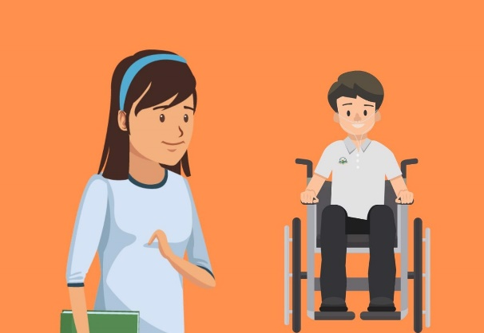

Disability
- Mencap Cymru – Mencap Wise is a service which is available to everyone in Wales, whether you are a person with a learning disability, a family member or a friend. They can give you the information you need to understand the rights of people with a learning disability and to support them to access services or challenge decisions. A helpline is available Monday to Friday, 9am – 5pm on 0808 8000 300. https://wales.mencap.org.uk/

Emotional health
- Heads Above the Waves – Support for young people suffering depression or self-harming. https://hatw.co.uk/straight-up-advice/

- Samaritans – A safe place for you to talk anytime. You can get in touch about anything that’s troubling you, no matter how large or small the issue feels. Call 116 123. https://www.samaritans.org/?nation=wales

- Rethink Mental Illness – Advice and information for vulnerable people with mental health issues. Call 0300 5000 927. https://www.rethink.org/

Crime
- Internet Watch Foundation – Report illegal images of children and young people. https://www.iwf.org.uk/

- Victim Support – Report hate crime in Wales. https://www.reporthate.victimsupport.org.uk/

- NSPCC – If you think that you or another child is in immediate danger, don’t delay – call 999 or the NSPCC on 0808 800 5000. https://www.nspcc.org.uk/

- SchoolBeat – A website from the All-Wales School Liaison Core Programme providing information and resources about drug and substance misuse, personal safety and safeguarding, and social behaviour and community. https://schoolbeat.cymru/en/



Online issues
- Internet Matters – Advice on online issues for children, young people and their families. https://www.internetmatters.org/

- Childnet International – Information and advice about all aspects of online safety. Find the latest information on the sites and services that you like to use, plus information about mobiles, gaming, downloading, social networking and much more. https://www.childnet.com/

